Спеціалізована школа №24 з поглибленим вивченням
російської мови та літератури

План-конспект
уроку з англійської мови
у 6-a класі
на тему:

«Спорт»

Розробила:
вчитель-спеціаліст
Мурзіна Ольга Анатоліївна

Київ-2014

Тема: “Sports”
Цілі навчання:
Повторити й активізувати лексичний матеріал з теми.
Практична мета: Навчити планувати зміст повідомлення та розвивати комунікативні здібності учнів
Освітня мета:
- Розширити та поглибити знання про культуру країни, мова якої навчається, а також рідної країни.
-Про будову іноземної мови, подібність до рідної мови и розбіжність з нею
Розвивальна мета:
- Розвивати вміння працювати в різних режимах навчання і контролю.
Виховна мета:
- практикувати учнів у письмі;
- розширити кругозір учнів щодо спортивних уподобань народів світу
Equipment: cards, instructions, pictures on the topic “Sport”, a tape recorder, an audio-cassette, a crossword, a textbook Alla Nesvit “We learn English 6”
PROCEDURE
Ι. INTRODUCTION
T: Good morning, my dear children. I am very glad and happy to see all of you today. Arrange the letters in the right order and you’ll get the topic of our lesson “ ROPST”. You are quite right! It’s sport. Today we’ll talk about different kinds of sports, what one shoud do to keep fit and what qualities a good sportsman shoud have.
Ι Ι. WARMING-UP
- T: What do you do to be healthy? What do you suggest and individual shoud do to keep fit?
Discuss it in pairs.
Possible answers;
- get rid of bad habits;
- do much exercise;
- avoid eating junk food;
- eat vitamins;
- go in for sports.
b) T: Answer the following questions filling in the spidergrame.

To be disciplined
To be fit
For enjoyment
To keep body slim
Why do people go in
for sport?

- T: Look at the pictures and say what kind of sport each of them presents.
figure skating volleyball
table tennis cycling
basketball football
gymnastics diving
ΙΙΙ. Speaking
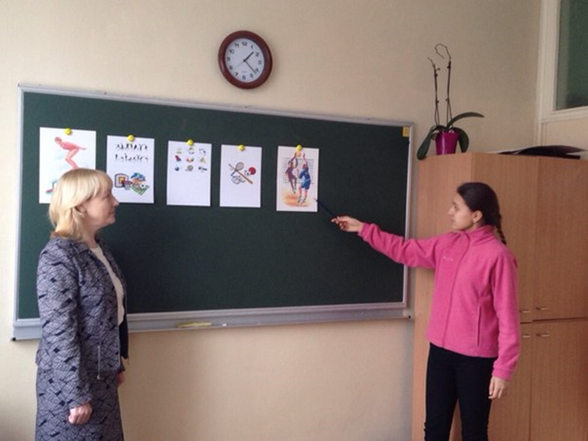
T: Why is sport so popular? Let’s sum up the information about sport we have discussed and draw a conclusion.
S1: People all over the world are fond of sport. That’s why it’s one of the things which unites people. Every morning all the year round people do their morning exercises. Television programmes about sport are very popular.
S2: Sport helps people remain healthy. It makes them disciplined in their daily activities. There are different kinds of sport: summer and winter, indoor and outdoor.
S3: Every year a great number of competitions are held in our country. Winners of national competitions take part in European and World Championships. The sportsmen who take the first place get gold medals. Those who take the second place get silver medals and who take the third place get bronze medals.
S4: Every 4 years the Olympic Games take place.
T: Do you know the history of Olympic Games? So, let’s read the text about the Olympic Games.
ΙV. Reading
Pre-reading task
T: Pay attention to the meaning of the word in italics, add the new words to you vocabulary.
For a long time, from 349 till 1896, there no Olympic Games. Since 1896 the best athletes of the world have met again every four years, as it was in Greece many, many years ago.
The capitals of many countries have been Olympic cities – Athens, Paris, London, Berlin, Helsinki, Rome, Tokyo, Mexico, Moscow and others.
There are Summer and Winter Olympic Games now. The best sportsmen compete in more than 30 different kinds of sport in modern Olympic Games. The Games have a lot of symbols. The five Olympic rings are the symbol of the unity of five continents. They are of five colours – red, yellow, blue, green and black – on a white field of the Olympic Flag.
In 2008 Peking became the city which hosted the Olympic Games again. The Olympic Games in China turned into a bright, beautiful and exciting festival of sports. Hundreds of sports grounds, stadiums, swimming pools were ready to meet the best athletes of the world.
Post-reading task
Answer the questions to the text
- When did the modern Olympic Games start?
- Which kinds of Olympic Games do we have nowadays?
- Which kinds of sport do the modern sportsmen complete in?
- What do you know about the symbols of the Olympic Games?
- Which cities were the Olympic capitals?
- Which city hosted Olympic Games in 2004?
V. Let’s relax and do physical exercises.
VΙ. Vocabulary practice
And now let’s play game “Hurry up”. I’ll divide you into two groups. On one side of the blackboard I wrote a list of familiar words for team A, and on the other one for team B. I’ll call out one of the word and the number of each team runs to the blackboard to cross out that word on your team’s side of the blackboard. Who’ll be quicker?
Team A Team B
1. wrestling 1. fencing
2. gymnastics 2. chess
3. figure skating 3. tobogganing
4. chess 4. wrestling
5. fencing 5. gymnastics
6. skiing 6. swimming
7. cycling 7. figure skating
8. skating 8. cycling
9. swimming 9. skiing
10. tobogganing 10. skating
VΙΙ. Dialogue speaking
T: Imagine your favourite sportsman is giving an interview to a journalist. You have his answers. Try to guess the questions of the journalist.
A:
B: I am Andriy Shevchenko.
A:
B: I am 31 years old.
A:
B: I am a footballer.
A:
B: I play for Ukrainian club “Dynamo”
A:
B: I live in Kyiv
A:
B: I have got two children.
A:
B: My hobby is reading.
A:
B: I like autumn best.

VΙΙΙ. Sport puzzle.
T: Find 12 sports here. The words go in different directions.
G | O | S | I | N | N | E | T | V | I | K | A | R | V | T
I | S | E | S | K | A | T | I | N | G | E | A | L | F | G
B | I | F | C | D | O | L | I | E | S | T | U | A | O | N
F | A | D | V | S | K | I | I | N | G | C | I | S | O | I
O | D | S | R | C | I | G | H | M | S | O | S | O | T | D
V | I | L | K | R | S | W | I | C | M | N | W | A | B | R
R | U | N | N | I | N | G | I | R | O | V | I | P | A | A
U | P | U | N | V | T | T | P | W | S | H | M | E | L | O
G | O | L | F | I | S | B | B | N | V | C | M | O | L | B
B | E | R | D | A | I | O | A | L | I | P | I | C | S | E
Y | R | G | N | L | A | Y | G | L | P | S | N | A | T | T
Z | O | M | L | D | F | M | R | S | L | A | G | C | E | A
L | Y | F | I | S | T | S | A | I | L | I | N | G | G | K
G | O | N | H | L | R | I | E | S | H | S | A | U | O | S
A | G | N | I | D | C | Y | C | F | R | E | H | S | O | N

ΙX. Home assignment
T: Make a project “My favourite kind of sport”.

